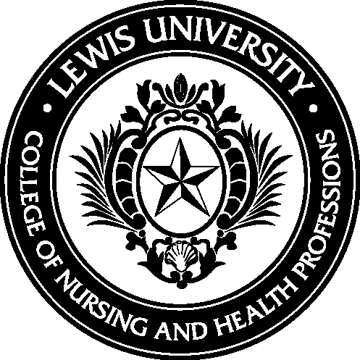
R.N.’S WORKING IN THE SCHOOLS
July 24 and 25, 2018, 9 a.m. – 4 p.m.(Closed)
ADDED SECTION July 26 and 27, 2018, 9 a.m. – 4 p.m.
Lewis University Oak Brook campus
1111 West 22nd Street, Suite 700
Oak Brook, IL 60523
(630) 573-1740
At the conclusion of the workshop, the learner will be able to:
- Identify state and federal laws that directly affect the practice of nursing in the school setting
- Identify health problems specific to the school setting
- Apply the nursing process in providing care for injuries and illnesses to students and staff in the school setting
- Apply legal resources and references affecting the practice of nursing in the school setting
- Identify resources for protecting the safety of students and staff in the prevention of violence and the implementation of crisis plans
Workshop fee: $250 includes handouts and Continuing Education credit.
Please register online at http://www.lewisu.edu/rn-working-in-schools
If you cannot attend, please notify Linda Gibbons immediately at (630-564-2396) or gibbonli@lewisu.edu.
Workshop is limited to the first 32 registrants. Minimum of 10 registrants. A waiting list will be instituted once the first 32 have registered. Refunds will not be given for cancellations after July 1, 2018.
This continuing nursing education activity is being submitted for approval by Lewis University College of Nursing and Health Professions to award 12 contact hours. Lewis University College of Nursing & Health Professions is an approved provider of nursing continuing education under the Illinois Nurse Practice Act Rules, Section 1300.130 Continuing Education.
Participants will need to attend the entire 2 day activity and submit an evaluation form to receive contact hours. This program is intended to provide information to facilitate the safe practice of nursing in a school setting. Planners & presenters disclose that there is no conflict of interest with this program.

